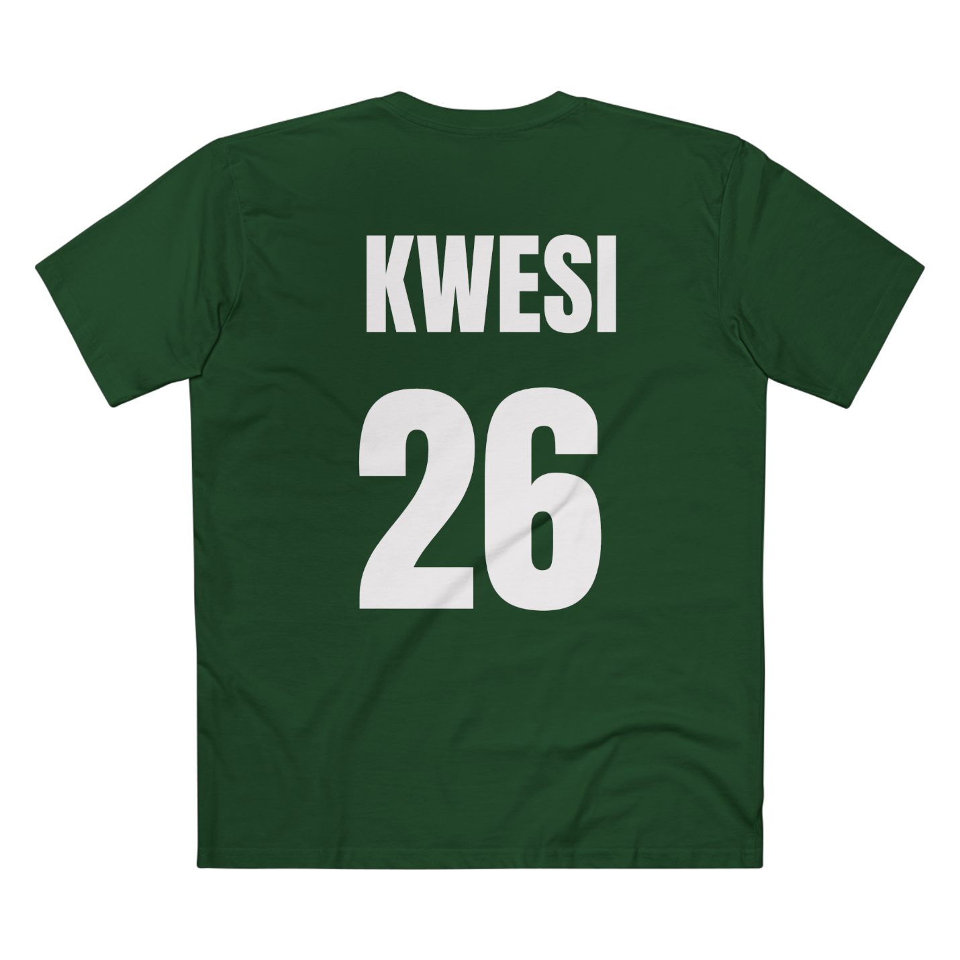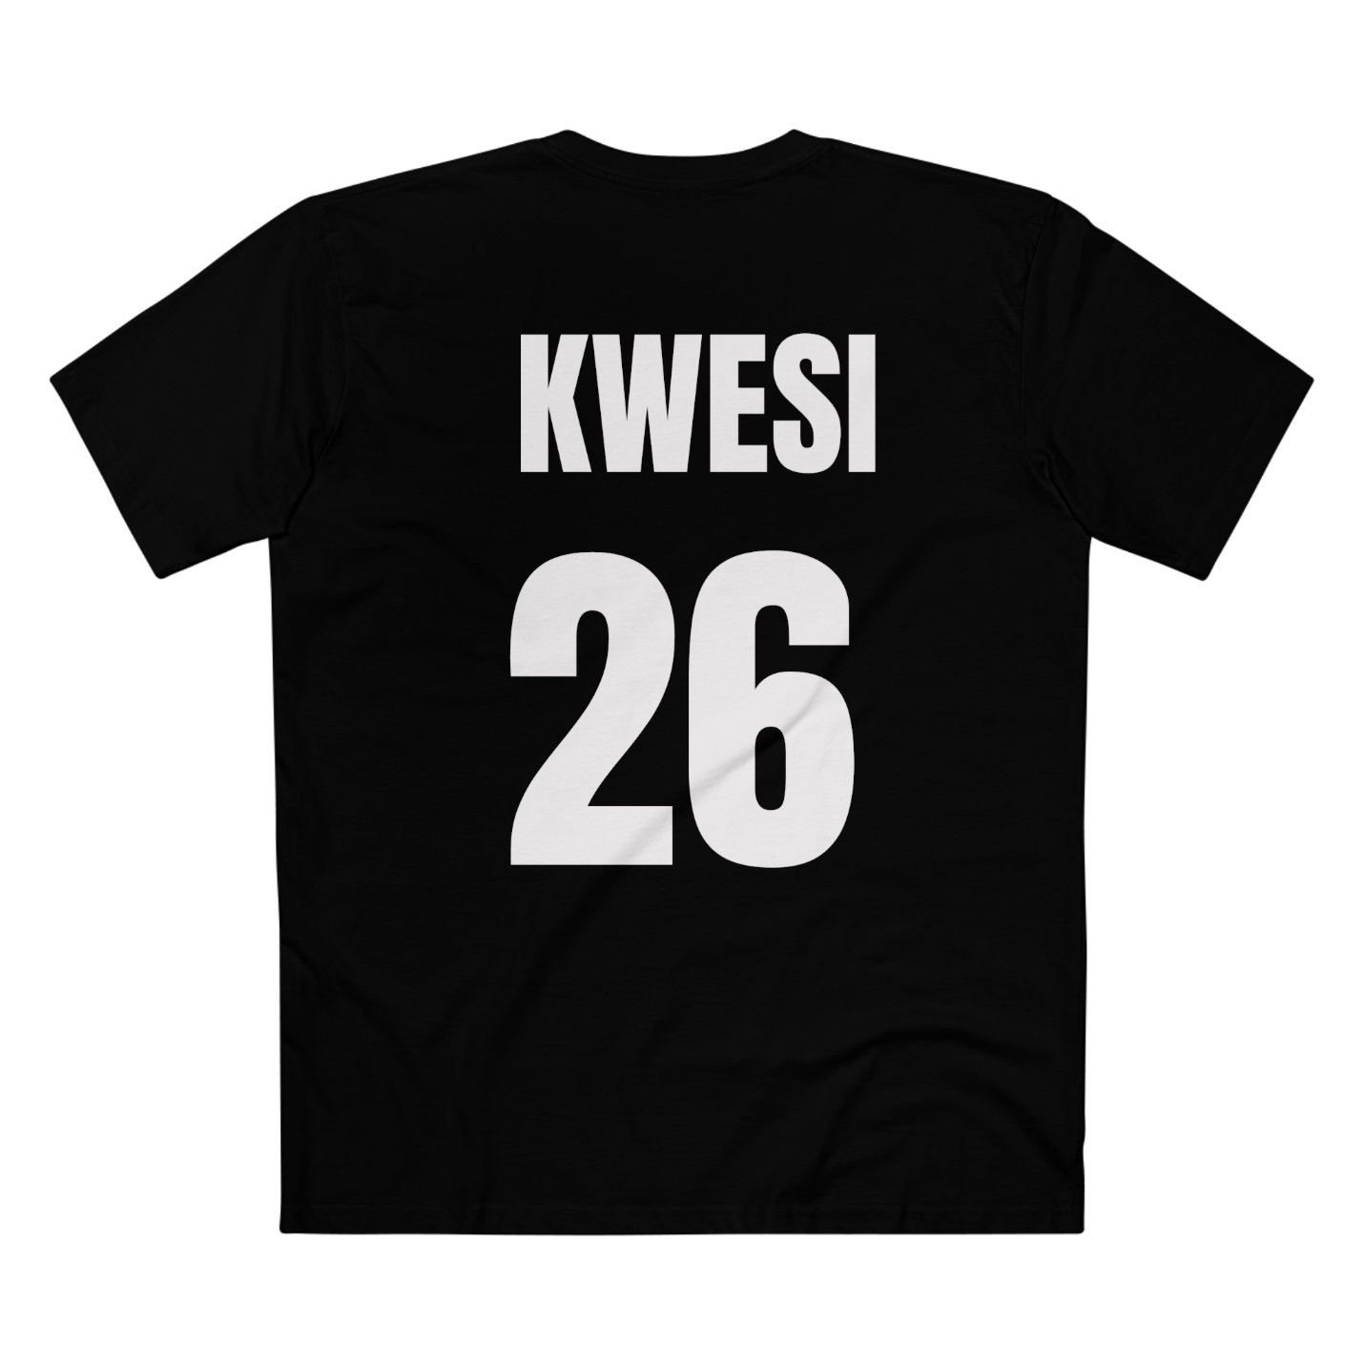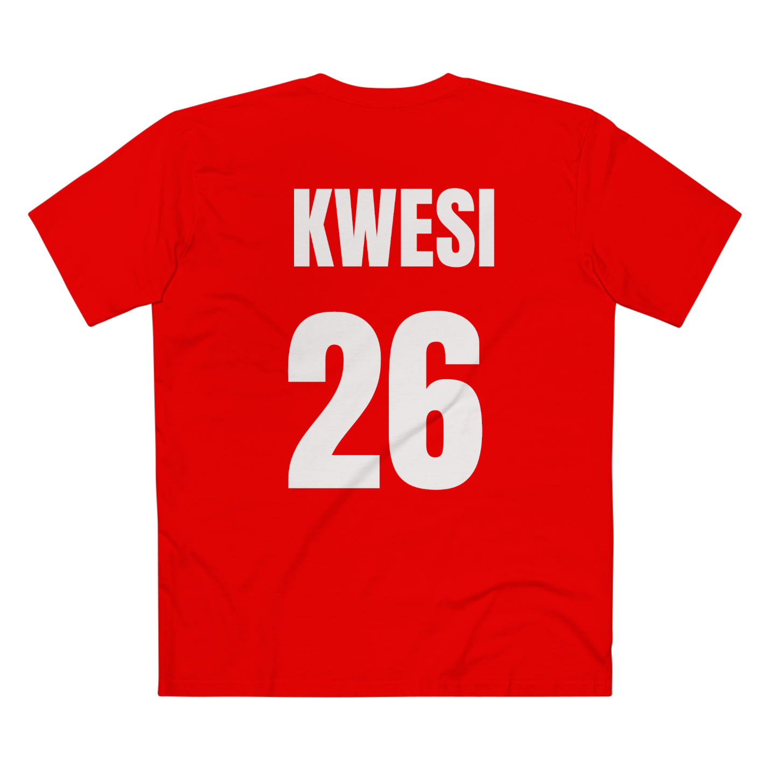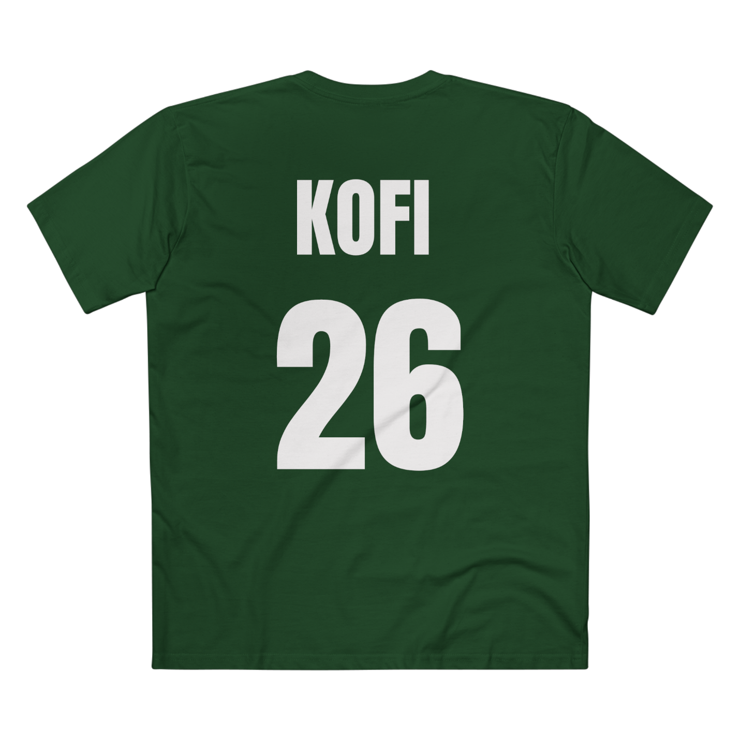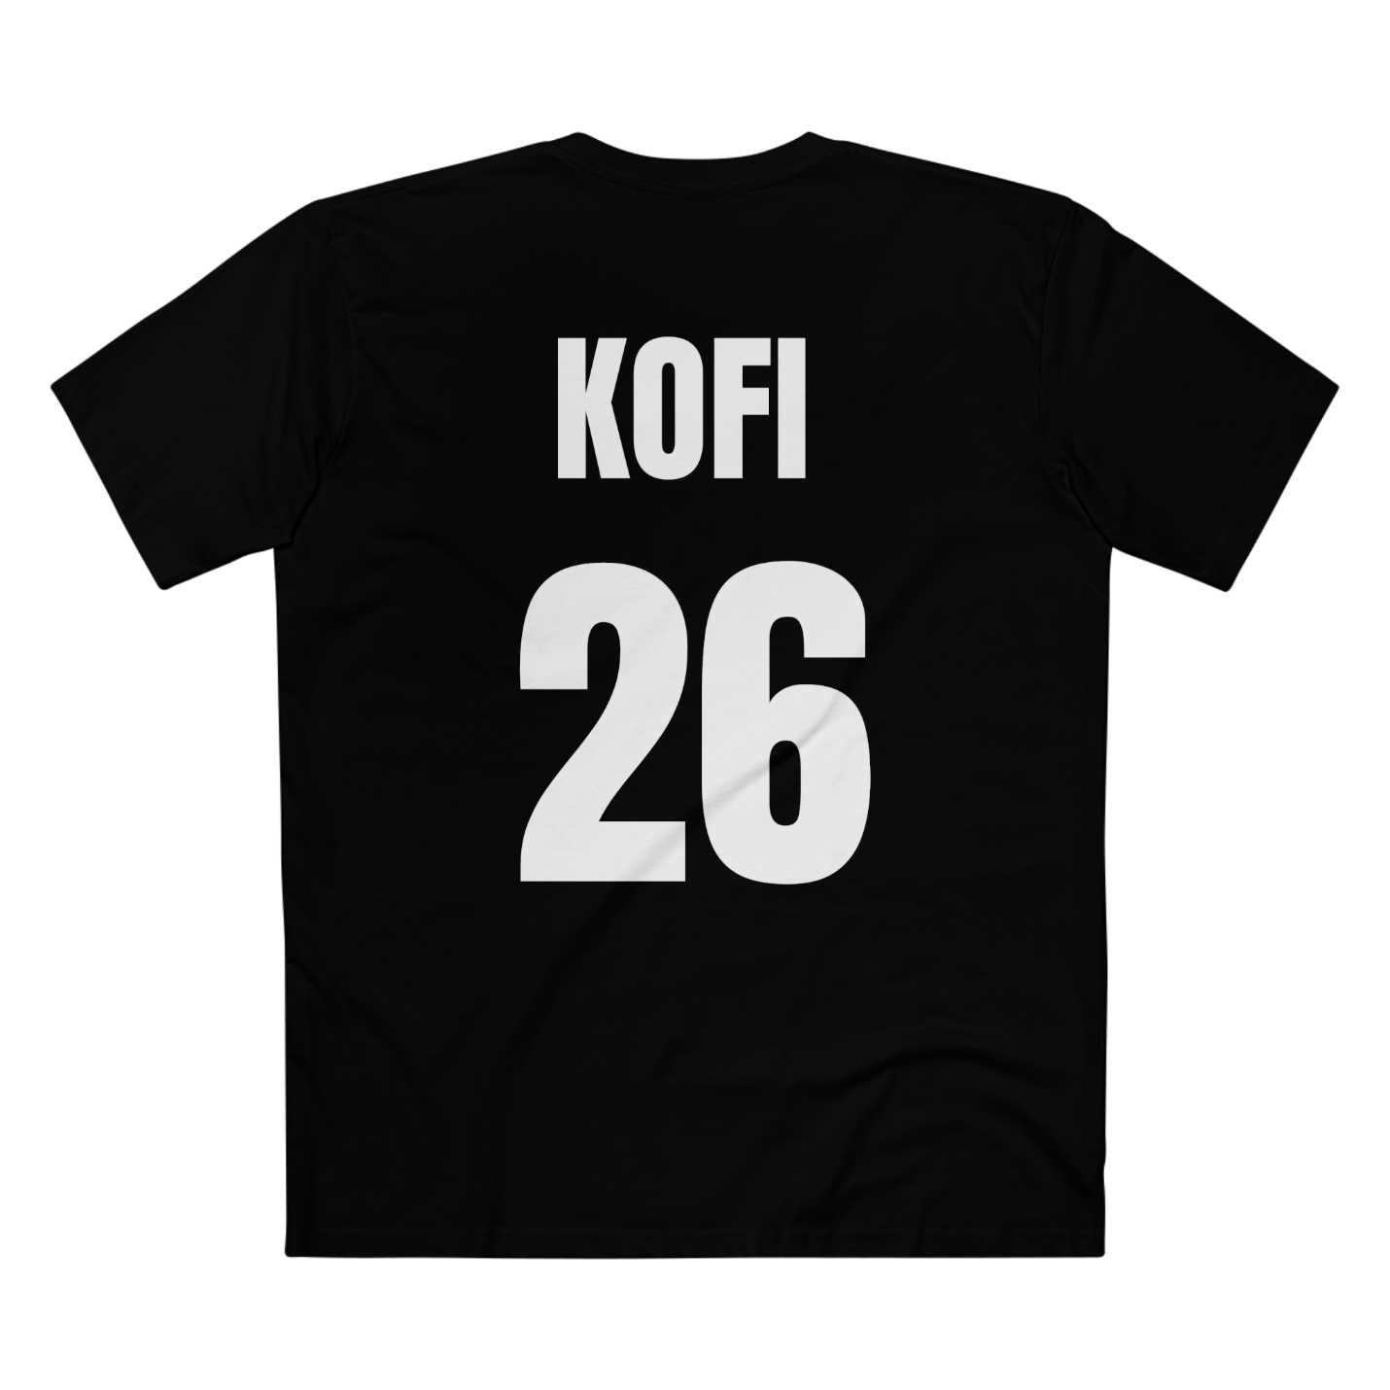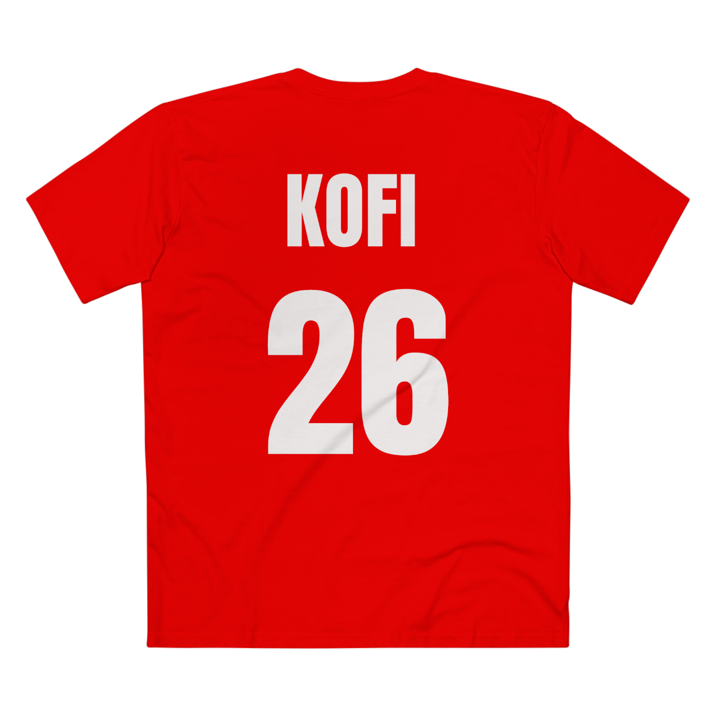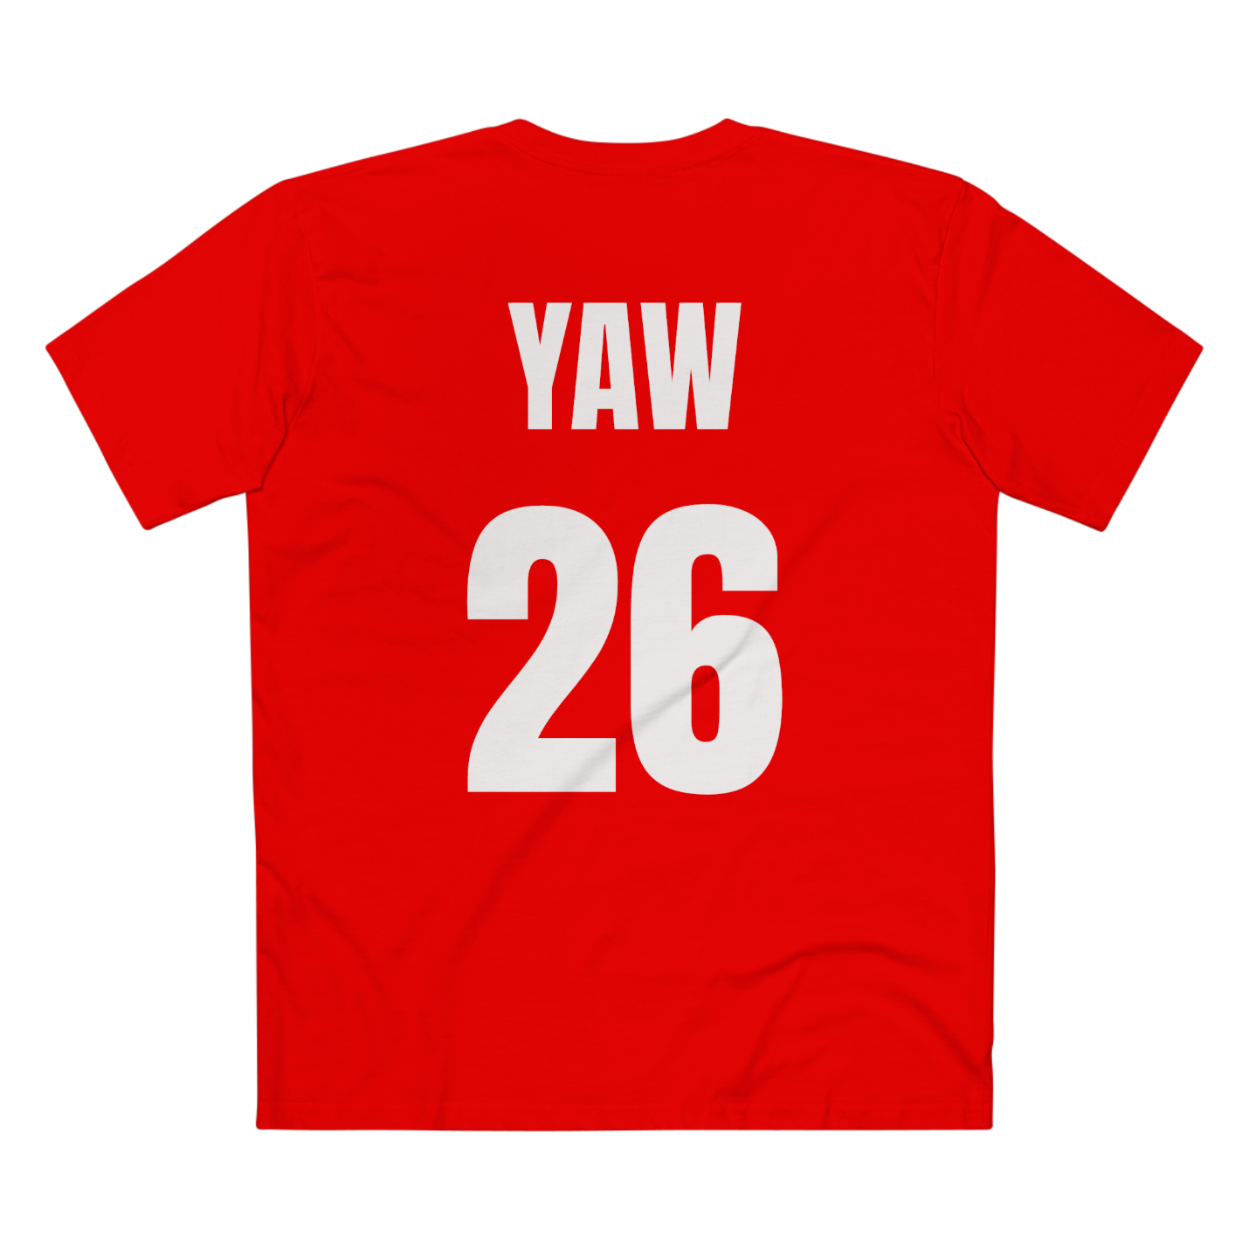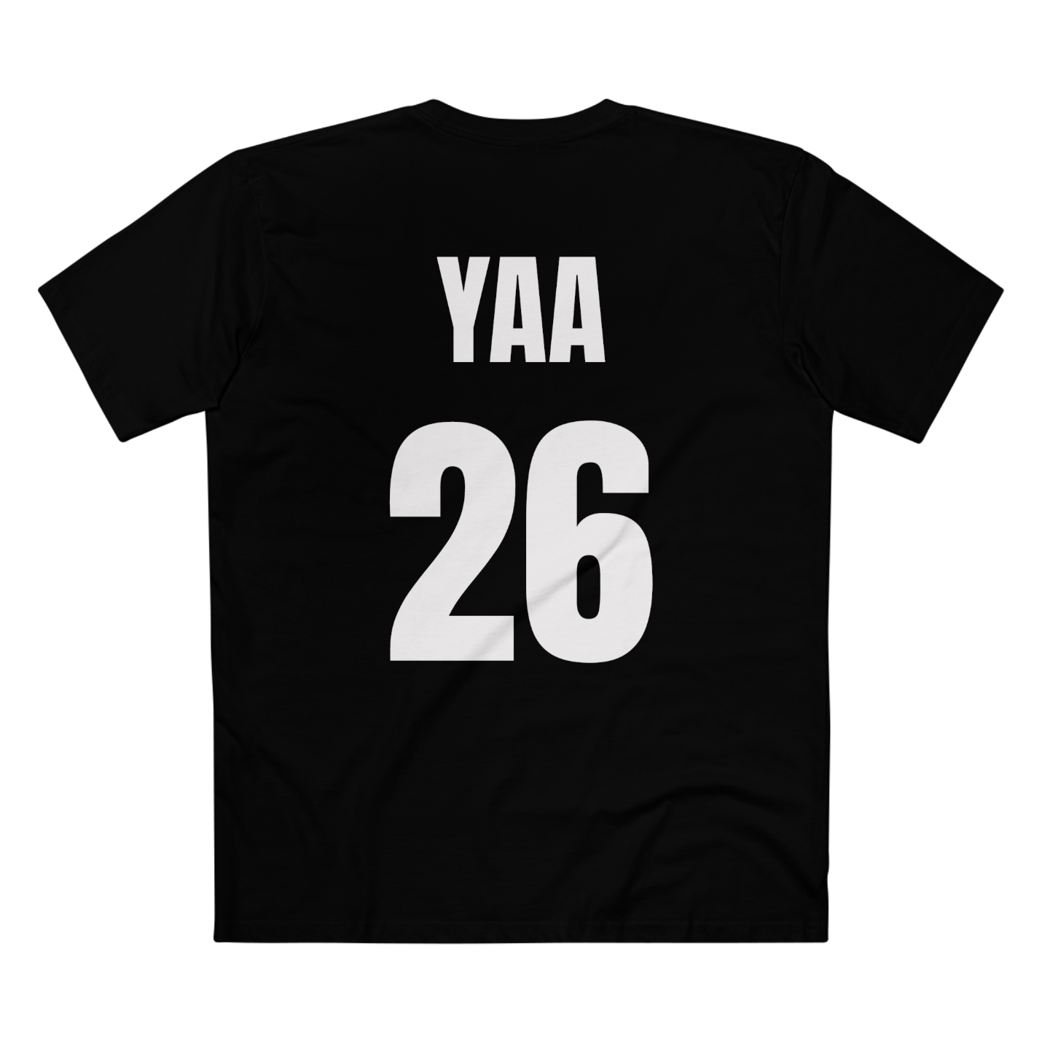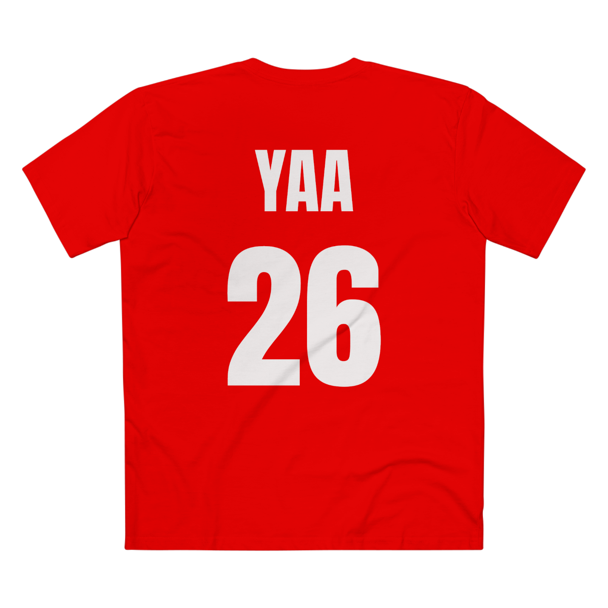

ALL ASSOCIATED LINKS
ADULTS
YAW
https://www.amazon.com/dp/B0H5THKN8L?th=1&psc=1
YAA
https://www.amazon.com/dp/B0H5T8PRCQ?th=1&psc=1
KWAKU
https://www.amazon.com/dp/B0H5TQKCCP?th=1&psc=1
AKUA
https://www.amazon.com/dp/B0H5TRD98Y?th=1&psc=1
KWABENA
https://www.amazon.com/dp/B0H5TL69V6?th=1&psc=1
ABENA
https://www.amazon.com/dp/B0H5T43CDS?th=1&psc=1
ADWOA
https://www.amazon.com/dp/B0H5TQDNKT?th=1&psc=1
KWADWOA
https://www.amazon.com/dp/B0H5T91CPJ?th=1&psc=1
ADJOA
https://www.amazon.com/dp/B0H5TC6S83?th=1&psc=1
KOJO
https://www.amazon.com/dp/B0H5TKGGM8?th=1&psc=1
AKOSUA
https://www.amazon.com/dp/B0H5T83M2H?th=1&psc=1
KWESI
https://www.amazon.com/dp/B0H5TGY75J?th=1&psc=1
KWASI
https://www.amazon.com/dp/B0H5TKT1KS?th=1&psc=1

KWAME
https://www.amazon.com/dp/B0H5TCB7LJ?th=1&psc=1
AMA
https://www.amazon.com/dp/B0H5T9GR2W?th=1&psc=1
KOFI
https://www.amazon.com/dp/B0H5T1VXLW?th=1&psc=1
AFIA
https://www.amazon.com/dp/B0H5TT8PJX?th=1&psc=1

BLACKSTAR
https://www.amazon.com/dp/B0H5TQGHW6?th=1&psc=1

